Message Center allows ED Providers to route information electronically, while enabling the ability to review and sign orders, document, and work with messages.

# Inbox Summary Tab

Documents contain transcribed and/or scanned documents for signature, co-signature, or documents to review.

* Forwarded Documents to Sign contains documents from care team members requiring signature from supervising physician.
* Orders to Approve contains orders requiring a co-signature.
  + **Orders to Approve** must be signed within 48 hours from the time it was entered.
* Renewal Orders are used when continuing orders are setup with a notification to send to the provider when the order is up for renewal.
* Messages contain patient communication from clinical, office staff, and providers. Messages are saved to the patient chart.

# Review and Sign Orders in Message Center

**STEP 1:** Click the **Message Center** button on the toolbar.

**STEP 2:** Select the **Orders** section in the left of the navigation pane.

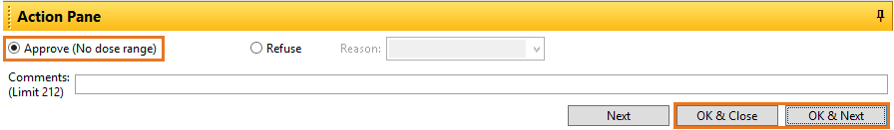**STEP 3**: Double-click the order to review.

**STEP 4:** Click the **Approve** button and **OK & Close** to sign the orderor **OK & Next** to sign the order and move to the next order.

# Refuse Orders in Message Center

**STEP 1:** Click the **Refuse** radio button.

**STEP 2:** Select the Refuse **Reason** from the drop-down menu.

**STEP 3:** Use **Comments** to write additional comments if necessary.

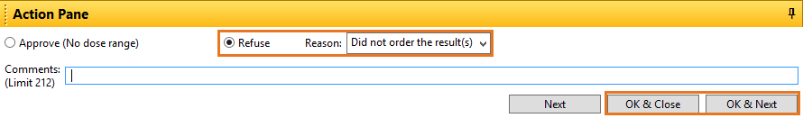**STEP 4:** Click **OK & Close** button or, to move to the next order, click **OK & Next**.

# Manage Documents

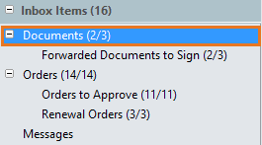The purpose of the Documents section is for provider review of content that has already been committed to the patient’s medical record or needs provider review.

* The number in parentheses indicates the number of unviewed documents and the total **new** items within the folder.
* If a provider opens a document (or an order) and doesn’t sign the item, the first number in parentheses will no longer reflect the opened document in the count, but the total will still include this document.

NOTE: It is possible for a Provider to see a set of parentheses with a zero as the first number, but this does not mean the inbox is empty. The first number indicates number of “new” items that have not been viewed.

# Managing Forwarded Documents to Sign

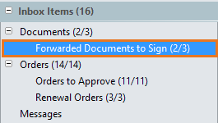Forwarded Documents populate in this folder when another Provider sends a document to the provider to review and sign.

**STEP 1**: Click **Forwarded Documents to Sign** under **Documents** in Inbox Items***.***

**STEP 2**: Double-click the note you wish to view and sign.

**STEP 3**: In the Action Pane, click **OK & Close** to sign and close the window, or click **OK & Next** to sign and open the next document for review.

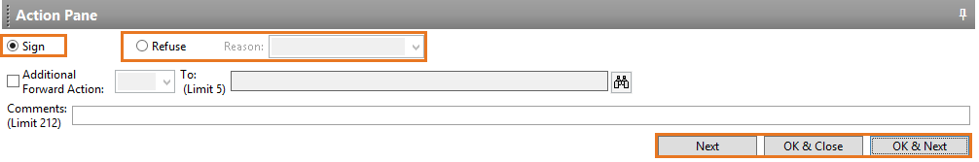NOTE: If you click Refuse, you need to document a reason why in the Reason field.

# Modify Forwarded Documents to Sign

**STEP 1:** Click **Forwarded Documents to Sign** under Documents in Inbox Items.

**STEP 2:** Double-click the document you wish to view and modify.

**STEP 3:** Select the **Modify** button in the toolbar.

**STEP 4:** Add any modifications to the In Progress document under the freetext areas and then click **Sign.**

# Adding an Addendum

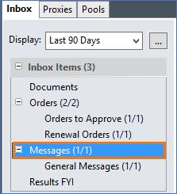

If an addendum is needed in a note, Coding will send the query in Message Center indicating the addendum needs to be added to the note.

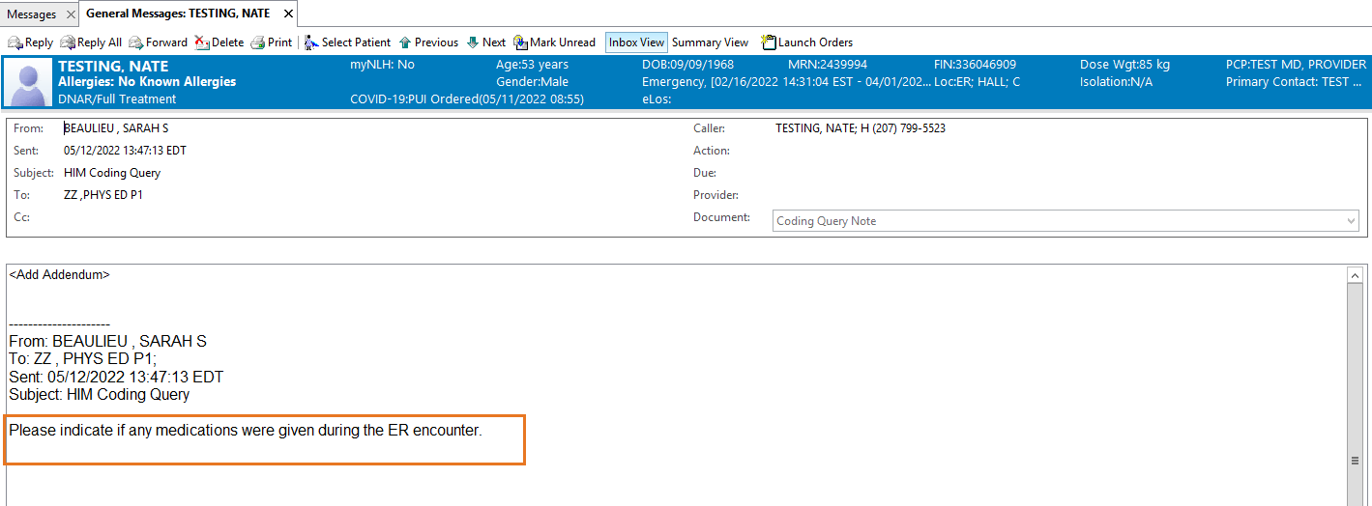

**STEP 1:** Select the message by double-clicking to view the query.

**STEP 2:** To open the document, as well as the chart to the correct encounter, navigate to the patient’s name next to the MRN search bar in the top right of the screen.

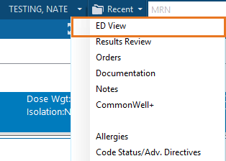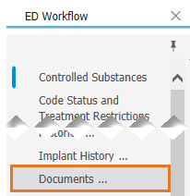

**STEP 3:** Click the drop down next to the patient’s name and select **ED View**.

**STEP 4:** Navigate to **Documents** component.

**STEP 5:** Select the ED Note and click **Modify**.

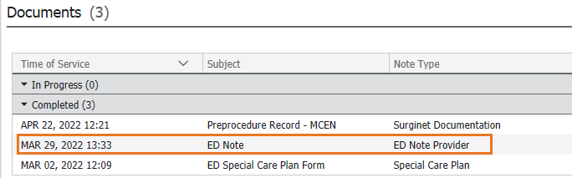

**STEP 6:** Insert addendum into ED Note.

**STEP 7:** Click **Sign & Save**.

**STEP 8:** Within Message Center, click **OK & Close** to sign the message or **OK & Next** to sign and open the next message.

# Refusing a Document

**STEP 1:** Open and review the document. If the document does not belong to the provider, the document must be sent back to HeIS.

**STEP 2:** In the **Action Pane**, select **Refuse** and select a reason from the **Reason** drop down.

**STEP 3:** Select **Additional Forward Action.**

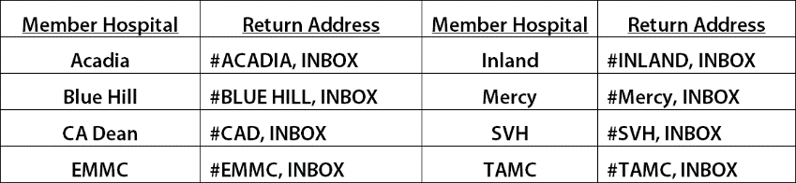**STEP 4:** Select the appropriate pool or person in the **To** field.

**STEP 5:** Enter a comment in the comments field indicating why the document is being forwarded for review, e.g., Not my patient.

**STEP 6:** Click **Ok & Next** to move to the next document.

# Sent Items and Trash

* Items in the Sent Items folder will automatically be purged from the system after a certain amount of time has elapsed.
* Items in the Trash folder can be manually removed by clicking the Trash folder then clicking the Empty Trash button.

**For questions regarding process and/or policies, please contact your unit’s Clinical Educator or Clinical Informaticist. For any other questions please contact the Customer Support Center at:**

**207-973-7728 or 1-888-827-7728.**