WellDoc is a digital health solution which supports multiple chronic conditions and comorbidities. The WellDoc application delivers personalized care to the patient population while providing health reports to clinical staff for review.
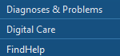
Ordering WellDoc
STEP 1: Within Cerner navigate to the Table of Contents on the left side of the screen and click Digital Care.
STEP 2: Once in the Digital Care platform, select the Order component on the left.
STEP 3: Choose the applicable language.
STEP 4: Select Order on the right to order the program for the patient.
    - This generates an email to the patient to download the WellDoc App and set up the account.
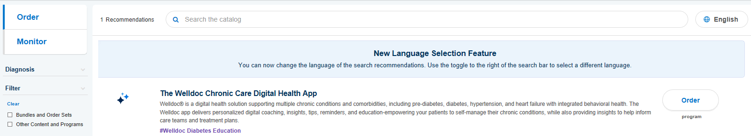
      - Once an order is placed, it can not be ordered again. The patient will get a reminder email seven days after the original email to set up their WellDoc account if not completed. If the patient needs assistance, they can call WellDoc Customer Service at 1-888-327-5345.
IMPORTANT: Patient should not download the WellDoc App from the App Store as it will not allow for linking to their Cerner chart.
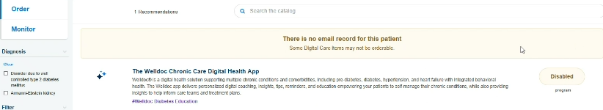
NOTE: If the patient does not have an email, this message will appear.
WellDoc Dashboard
Once a patient has registered within the WellDoc application, clinical staff and providers are able to track data via the Health Reports. Information such as blood sugars, which include trends; weight and current medications will be face up for review.
STEP 1: Within Cerner navigate to the Table of Contents on the left side of the screen and click Digital Care.
STEP 2: Once in the Digital Care platform, select the Monitor component on the left.
    - Two tiles will appear, one for education content prescribed and the other for the program prescribed with WellDoc dashboards.
      - The WellDoc dashboard contains datapoints and the Health Report of patient’s activity and tracking progress within the app.
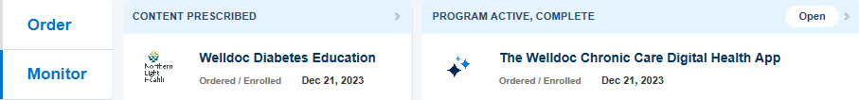
STEP 3: Click Open on the Program Active, Complete tile.
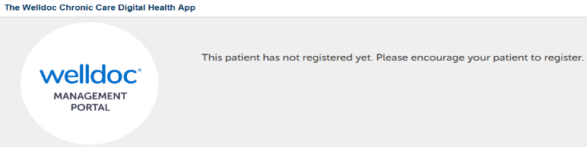
NOTE: If the tile states Program Prescribed and Open is clicked, a message will appear.
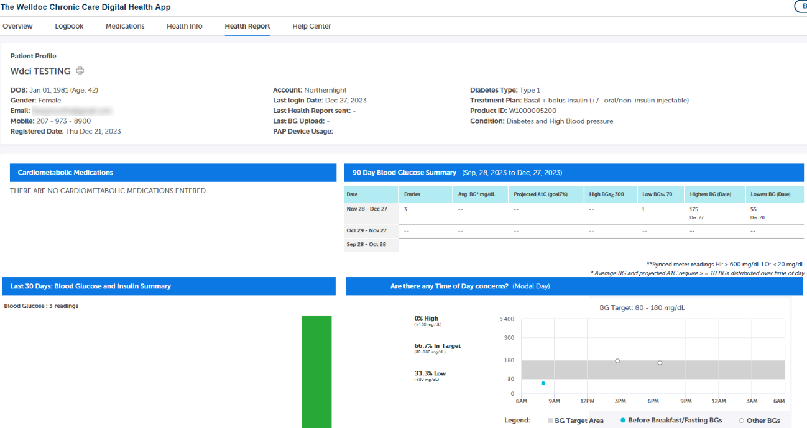
IMPORTANT: There are no alerts or notifications if a patient uploads data. It is the patient’s responsibility to call or send a message if they want the provider to review abnormalities/trends.
For questions regarding process and/or policies, please contact your unit’s Clinical Educator or Clinical Informaticist. For any other questions please contact the Customer Support Center at:
207-973-7728 or 1-888-827-7728.

