Ways to Check your Charges are Completed:
- DAILY- use the OPEN tab on your daily Organizer
Check OPEN items
Look for Notes not completed, and Charges Not Completed
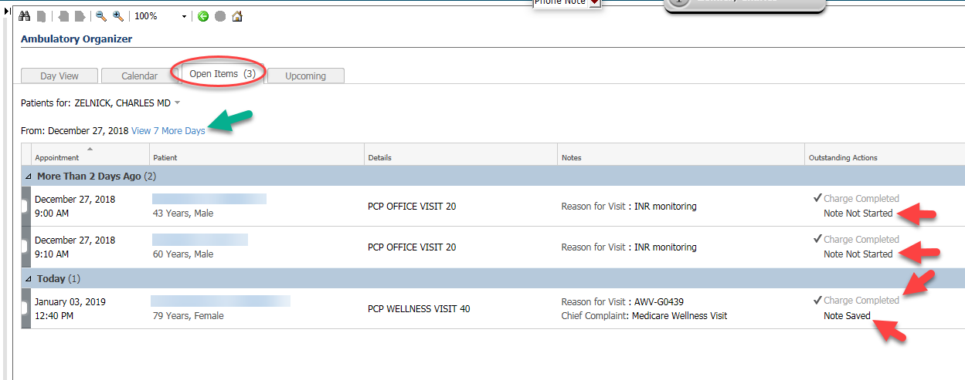

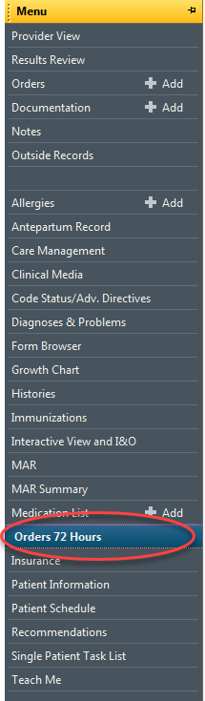
- But Be Careful; sometimes a minor charge will mark the FIN as “Charge Completed” when the full Office visit has not been charged out: If you are within 72 hours of date of FIN services, you can check in the chart with 72 HOUR lookback: In this example which above shows “Charges Completed” this is because the nurse Billed out the Depression Screen; but the Provider has not yet added the CPT for the E&M Office visit:
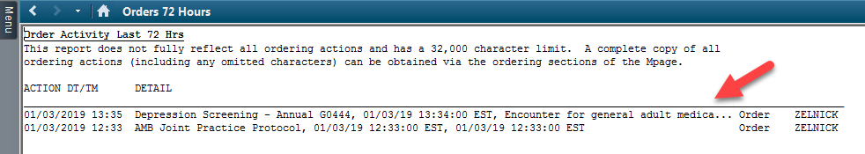

- A final somewhat Ugly way to check charges is to actually go into the ORDERS Module and look them up: Check the Orders in Non-Categorized section and the dates to see if you billed anything for the date of service. 