Stupid Cerner Tricks: Volume III
“RETURN OF THE RECOMMENDATIONS”
Recommendations are the way we keep track of preventive services AND recommended disease-based testing. Both types of services are combined in our version of Cerner (i.e. there is not a separate Preventive Services tool like Care Gaps in Centricity.)
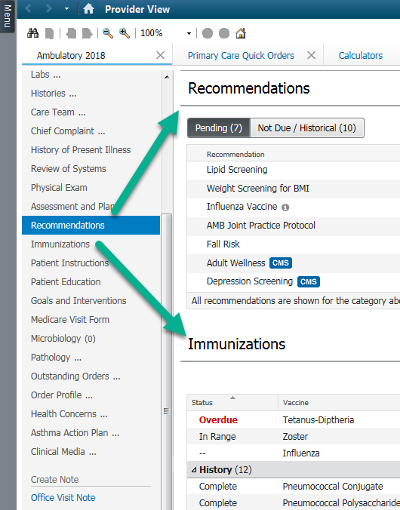
Recommendations had a lot of problems at Go Live; but an update was put into place the last week of December 2019 to correct many issues. Ongoing vetting and improvement of this component will occur. A few items may still be getting fixed.
RECOMMENDATIONS are found on the Workflow Mpage. Its really a good idea to organize Recommendations and Immunizations right next to each other in your left hand Mpage Component list (drag and drop to move it).
There is a Flyer that also shows basics of this Component, at: http://ci.emhs.org/Flyers/Pathways-to-Our-Future/Provider/Fall,-2018/Recommendations-Component-(1).aspx
Below are some further tips.
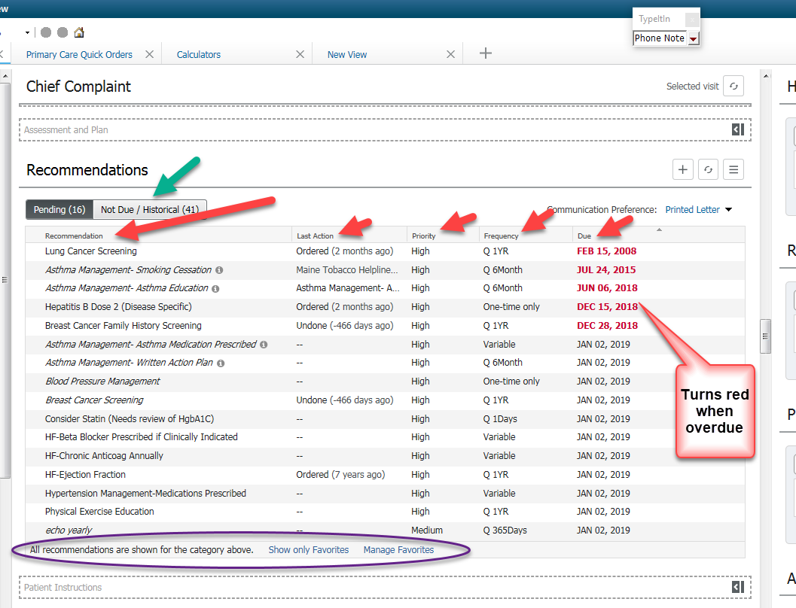
Green arrow: toggles between Due and Not Due Recommendations
Red Arrows: Columns headers
Purple oval: Providers have option to only see Favorites. Not so useful for Primary Care, but for Specialists: i.e. if you are Cardiologist, you would not want to see Pap smear recommendations, but you might mark only Cardiac associated items, like Lipid testing as a Favorite and follow by toggling the “Show Only Favorites Button”.
Here is how to Manage Favorites: (This is also a good place to familiarize yourself with the list of possibilities). This example is how a Cardiologist might choose just relevant items:
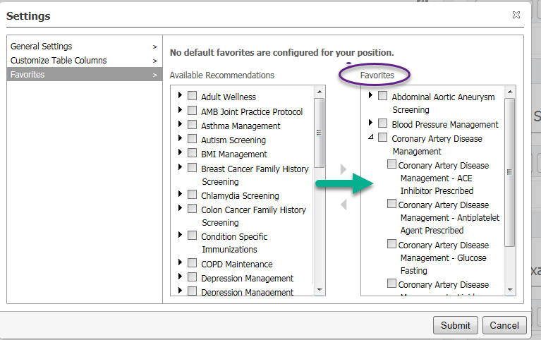
And here is how it looks with Favorites turned on for a Cardiologist:
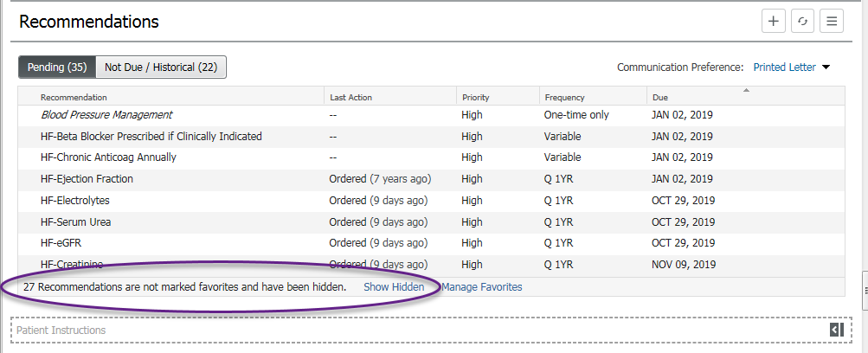
Dealing with Individual Recommendations:
Each Recommendation has its own rule about what “Satisfies” it. [Soundtrack for this part of page is Rolling Stones song, “Satisfaction”- play it in your head now…].
Depending on the item, there are different ways they get Satisfied.
- Automatic: - i.e patient is due for Flu shot, and flu shot is given/documented; now the Recommendation is Satisfied.
- Measurements: Patient is due for height; or Depression Screening. These are recorded on Nursing intake form, and Recommendation is Satisfied.
- Interventions: You counsel the patient about BMI or Exercise in the office- click Actions and you get a Powerform that allows you to document what you did. This Satisfies. 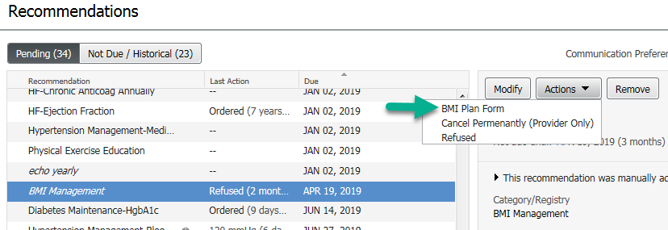
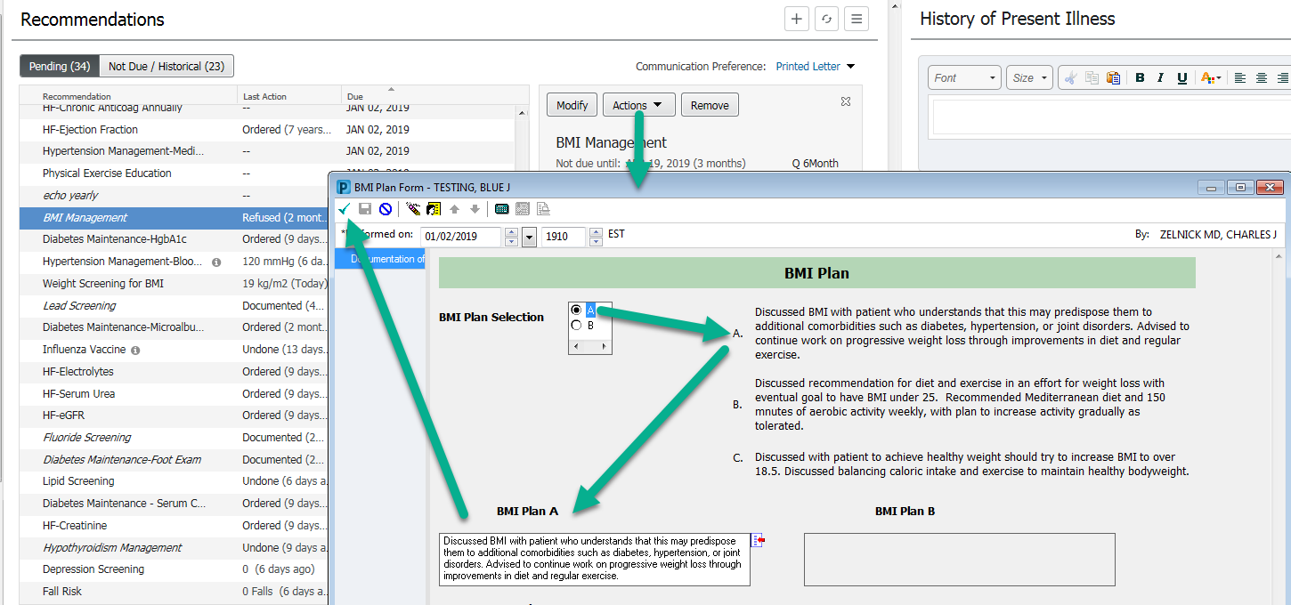
- Orders: sometimes just Ordering a service will satisfy the Recommendation; e.g. if you Order a FIT test for Colorectal Screening, it will Satisfy the Recommendation (BUT BEWARE, it does not track if the patient actually brought back the stool sample!- you may want to have a workflow to pick up noncompliant patients).
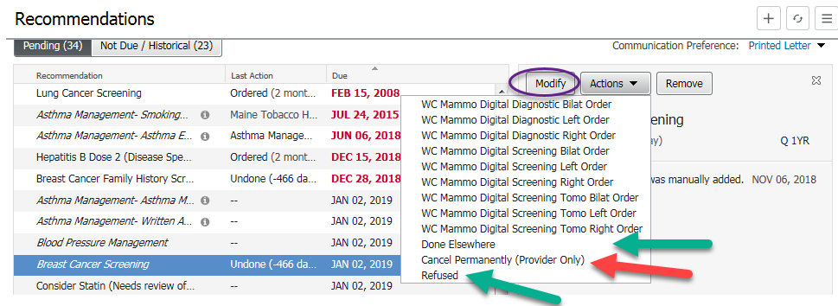
- Manual: Sometimes you have to go in and Satisfy the Recommendation yourself. E.g the patient Refuses their flu shot. Or the patient had a Colonoscopy done at Mass General last year and its not been recorded in our system.
WARNING: Cancel Permanently (Provider Only) cancels the Recommendation, and you can’t get it back ever again. Use this only to do something like cancel Mammogram Recommendations on a patient who has had a double mastectomy.
Note “Done Elsewhere” will be CHANGED to “Done” in the future. I currently change this in my head to “Done Somewhere”- because sometimes it is DONE in my own office.
Clicking on this choice allows you to enter the result of a test or service done in the office or anywhere on Earth. Here is an example of clicking Done Elsewhere for Breast Cancer..
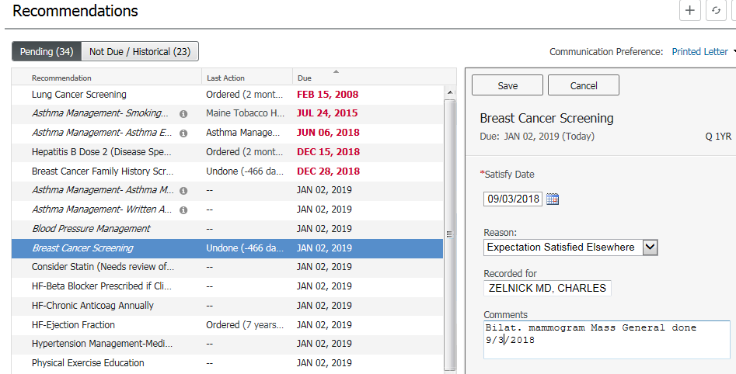
So SAVE this information, BUT YOU ARE NOT DONE YET: The system will usually set the recall date at 1 year. If you want a different interval, once you save he result Done Elsewhere. So click the MODIFY button (circled in Purple 2 screenshots back up this page) and set the Interval or set a new Due Date (use tiny pencil).
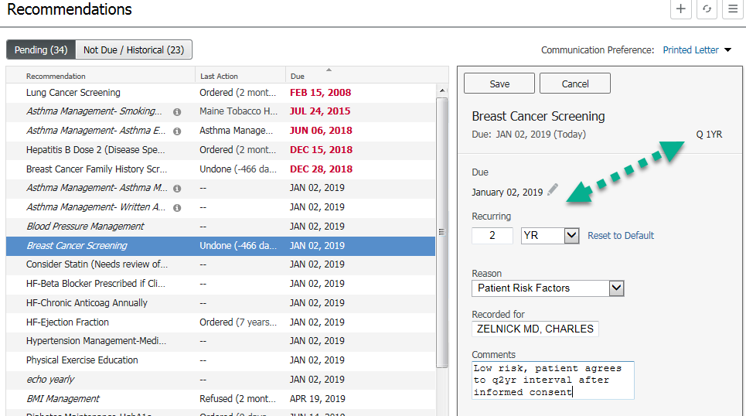
This step is especially important for Mammograms, DEXA, Colonoscopy.
This is where each office will have to work out their local workflow as to who and how this data gets entered in the record. But everyone should be involved.
MAs and Nurses may go through the workflows while rooming the patient and either Satisfy them or Enter/Propose Orders to get them Satisfied.
What if you want to track something NOT in recommendations?
Some examples:
- Following noncritical but known Carotid Stenosis with Ultrasounds
- Abnormal pap smears
- Repeat MOCA cognitive exam after 1 year interval
- Annual iron levels in patient with Hemochromatosis
These are entered as FREE TEXT entries. Click the Plus + sign next to Recommendations and enter it:
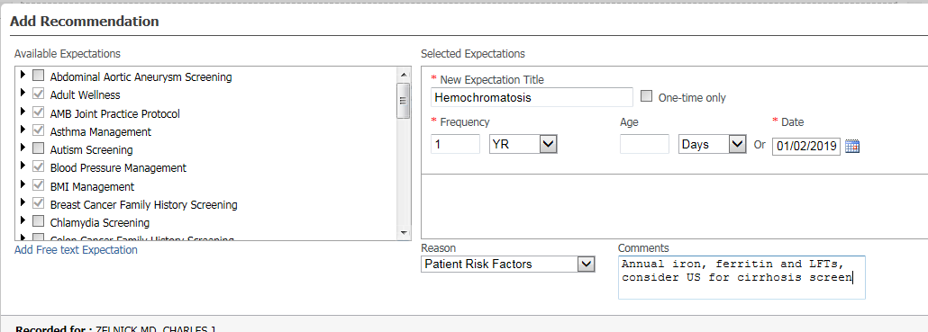
CMS Icons
You may notice little blue CMS icons. These indicate Recommendations that CMS recommends out of their database.
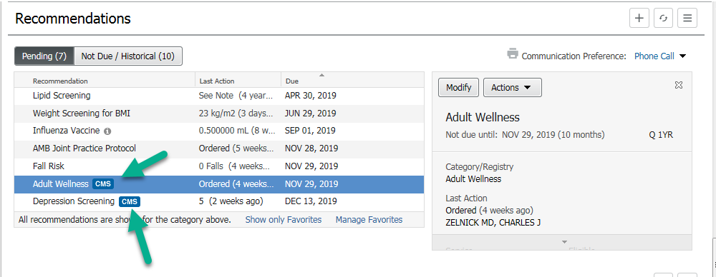
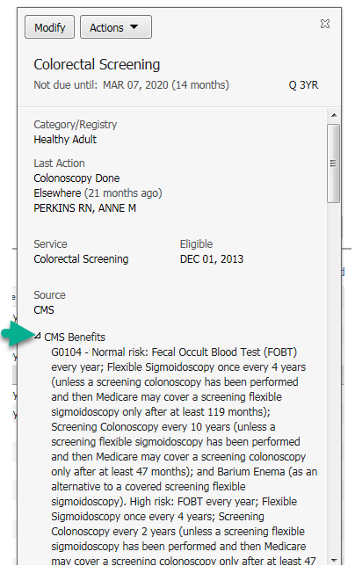
If you open up the item and click the little arrow you can find all the rules for Medicare eligibility. I don’t know why any provider would want to do this, but its there if you are interested….
More importantly, notice that even though this Recommendation was Satisfied in Dec 2013, and NOT due until March 2020, you still get the CMS icon.
The CMS icon has nothing to do with SATISFACTION.
(Cultural literacy reference, esp if you were born after 1980: https://www.youtube.com/watch?v=lM9O-qDpRSY)

